Baha’i Wedding

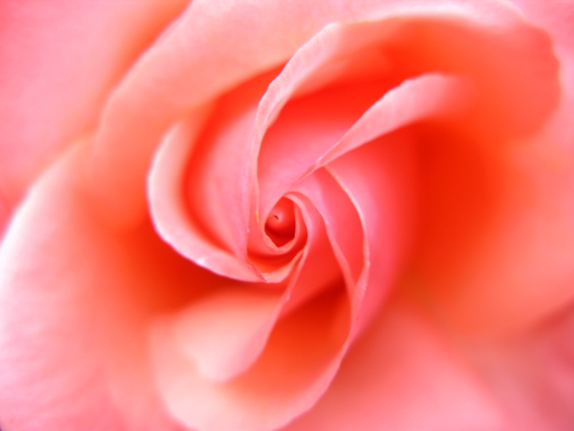

Program (example)

Arrival & Photo-Taking

Wedding Ceremony
Entrance of the bride and groom
Prayers
Selected Readings
Wedding Vow
Selected Readings

Reception
Speeches by bride and groom
Group Photo
Speeches by Parents/Families
Slide show
Refreshments
Music
Speeches by friends

Closing (Prayers)

Prayers & Readings
- He is the Bestower, the Bounteous!
Praise be to God, the Ancient, the Ever-Abiding, the Changeless, the Eternal! He Who hath testified in His Own Being that verily He is the One, the Single, the Untrammelled, the Exalted. We bear witness that verily there is no God but Him, acknowledging His oneness, confessing His singleness. He hath ever dwelt in unapproachable heights, in the summits of His loftiness, sanctified from the mention of aught save Himself, free from the description of aught but Him.
And when He desired to manifest grace and beneficence to men, and to set the world in order, He revealed observances and created laws; among them He established the law of marriage, made it as a fortress for well-being and salvation, and enjoined it upon us in that which was sent down out of the heaven of sanctity in His Most Holy Book. He saith, great is His glory: “Marry, O people, that from you may appear he who will remember Me amongst My servants; this is one of My commandments unto you; obey it as an assistance to yourselves.”
Bahá’u’lláh
II. He is God! O peerless Lord! In Thine almighty wisdom Thou hast enjoined marriage upon the peoples, that the generations of men may succeed one another in this contingent world, and that ever, so long as the world shall last, they may busy themselves at the Threshold of Thy oneness with servitude and worship, with salutation, adoration and praise. “I have not created spirits and men, but that they should worship me.” Wherefore, wed Thou in the heaven of Thy mercy these two birds of the nest of Thy love, and make them the means of attracting perpetual grace; that from the union of these two seas of love a wave of tenderness may surge and cast the pearls of pure and goodly issue on the shore of life. “He hath let loose the two seas, that they meet each other: Between them is a barrier which they overpass not. Which then of the bounties of your Lord will ye deny? From each He bringeth up greater and lesser pearls.”
O Thou kind Lord! Make Thou this marriage to bring forth coral and pearls. Thou art verily the All-Powerful, the Most Great, the Ever-Forgiving.
‘Abdu’l-Bahá

III. The pious deeds of the monks and priests among the followers of the Spirit - upon Him be the peace of God - are remembered in His presence. In this Day, however, let them give up the life of seclusion and direct their steps towards the open world and busy themselves with that which will profit themselves and others. We have granted them leave to enter into wedlock that they may bring forth one who will make mention of God, the Lord of the seen and the unseen, the Lord of the Exalted Throne.
Bahá'u'lláh
IV. …man should know his own self, and recognize that which leadeth unto loftiness or lowliness, glory or abasement, wealth or poverty.
Bahá'u'lláh
V. Bahá'í marriage is union and cordial affection between the two parties. They must, however, exercise the utmost care and become acquainted with each other’s character. This eternal bond should be made secure by a firm covenant, and the intention should be to foster harmony, fellowship and unity and to attain everlasting life….
'Abdu'l-Bahá
VI. Verily in the Book of Bayan (the Báb's, Revelation) the matter is restricted to the consent of both (bride and bridegroom). As we desired to bring about love and friendship and the unity of the people, therefore We made it conditional upon the consent of the parents also, that enmity and ill-feeling might be avoided.
Bahá'u'lláh

Marriage Vow
“We will all, verily, abide by the Will of God.”

VII. Glory be unto Thee, O my God! Verily, this Thy servant and this Thy maidservant have gathered under the shadow of Thy mercy and they are united through Thy favor and generosity. O Lord! Assist them in this Thy world and Thy kingdom and destine for them every good through Thy bounty and grace. O Lord! Confirm them in Thy servitude and assist them in Thy service. Suffer them to become the signs of Thy Name in Thy world and protect them through Thy bestowals which are inexhaustible in this world and the world to come. O Lord! They are supplicating the kingdom of Thy mercifulness and invoking the realm of Thy singleness. Verily, they are married in obedience to Thy command. Cause them to become the signs of harmony and unity until the end of time. Verily, Thou art the Omnipotent, the Omnipresent and the Almighty!
‘Abdu’l-Bahá

VIII. Bahá'í marriage is the commitment of the two parties one to the other, and their mutual attachment of mind and heart. Each must, however, exercise the utmost care to become thoroughly acquainted with the character of the other, that the binding covenant between them may be a tie that will endure forever. Their purpose must be this: to become loving companions and comrades and at one with each other for time and eternity. . . . The true marriage of Bahá'ís is this, that husband and wife should be united both physically and spiritually, that they may ever improve the spiritual life of each other, and may enjoy everlasting unity throughout all the worlds of God. This is Bahá'í marriage.
'Abdu'l-Bahá:

IX. It is highly important for man to raise a family. So long as he is young, because of youthful complacency, he does not realize its significance, but this will be a source of regret when he grows old….In this glorious Cause the life of a married couple should resemble the life of the angels in heaven - a life full of joy and spiritual delight, a life of unity and concord, a friendship both mental and physical. The home should be orderly and well organized. Their ideas and thoughts should be like the rays of the sun of truth and the radiance of the brilliant stars in the heavens. Even as two birds they should warble melodies upon the branches of the tree of fellowship and harmony. They should always be elated with joy and gladness and be a source of happiness to the hearts of others. They should set an example to their fellow-men, manifest true and sincere love towards each other and educate their children in such a manner as to blazon the fame and glory of their family."
'Abdu'l-Bahá:

Closing Prayers

O my Lord, O my Lord! These two bright orbs are wedded in Thy love, conjoined in servitude to Thy Holy Threshold, united in ministering to Thy Cause. Make Thou this marriage to be as threading lights of Thine abounding grace, O my Lord, the All-Merciful, the luminous rays of Thy bestowals, O Thou the Beneficent, the Ever-Giving, that there may branch out from this great tree boughs that will grow green and flourishing through the gifts that rain down from Thy clouds of grace.
Verily, Thou art the Generous. Verily, Thou art the Almighty. Verily, Thou art the Compassionate, the All-Merciful.
‘Abdu’l-Bahá

Marriage Tablet
(Note: This Tablet is attributed to Abdu’l-Baha but not formerly confirmed by the Baha’i World Centre. It therefore cannot be treated as authored by Abdu’l-Baha; however, it can be used at a wedding with the above understanding)
The bond that unites hearts most perfectly is loyalty. True lovers once united must show forth the utmost faithfulness one to another. You must dedicate your knowledge, your talents, your fortunes, your titles, your bodies and your spirits to God, to Bahá'u'lláh and to each other. Let your hearts be spacious, as spacious as the universe of God!
Allow no trace of jealousy to creep between you, for jealousy, like unto poison, vitiates the very essence of love. Let not the ephemeral incidents and accidents of this changeful life cause a rift between you. When differences present themselves, take counsel together in secret, lest others magnify a speck into a mountain. Harbour not in your hearts any grievance, but rather explain its nature to each other with such frankness and understanding that it will disappear, leaving no remembrance. Choose fellowship and amity and turn away from jealousy and hypocrisy.
Your thoughts must be lofty, your ideals luminous, your minds spiritual, so that your souls may become a dawning-place for the Sun of Reality. Let your hearts be like unto two pure mirrors reflecting the stars of the heaven of love and beauty.
Together make mention of noble aspirations and heavenly concepts. Let there be no secrets one from another. Make your home a haven of rest and peace. Be hospitable, and let the doors of your house be open to the faces of friends and strangers. Welcome every guest with radiant grace and let each feel that it is his own home.
No mortal can conceive the union and harmony which God has designed for man and wife. Nourish continually the tree of your union with love and affection, so that it will remain ever green and verdant throughout all seasons and bring forth luscious fruits for the healing of the nations.
O beloved of God, may your home be a vision of the paradise of Abha, so that whosoever enters there may feel the essence of purity and harmony, and cry out from the heart: Here is the home of love! Here is the palace of love! Here is the nest of love! Here is the garden of love!
Be like two sweet-singing birds perched upon the highest branches of the tree of life, filling the air with songs of love and rapture.
Lay the foundation of your affection in the very center of your spiritual being, at the very heart of your consciousness, and let it not be shaken by adverse winds.
And, when God gives you sweet and lovely children, consecrate yourselves to their instruction and guidance, so that they may become imperishable flowers of the divine rose-garden, nightingales of the ideal paradise, servants of the world of humanity, and the fruit of the tree of your life.
Live in such harmony that others may take your lives for an example and may say one to another: Look how they live like two doves in one nest, in perfect love, affinity and union. It is as though God had kneaded the very essence of their beings for the love of one another.
Attain the ideal love that God has destined for you, so that you may become partakers of eternal life forthwith. Quaff deeply from the fountain of truth, and dwell all the days of your life in the paradise of glory, gathering immortal flowers from the garden of divine mysteries.
Be to each other as heavenly lovers and divine beloved ones dwelling in a paradise of love. Build your nest on the leafy branches of the tree of love. Sail upon the shoreless sea of love. Walk in the eternal rose-garden of love. Bathe in the shining rays of the sun of love. Be firm and steadfast in the path of love. Perfume your nostrils with the fragrances from the flowers of love. Attune your ears to the soul-entrancing melodies of love. Let your aims be as generous as the banquets of love, and your words as a string of white pearls from the ocean of love. Drink deeply of the elixir of love, so that you may live continually in the reality of Divine Love.
Abdu’l-Baha

